

database management systems

Cycle Sheet – 2

Name: VIBHU KUMAR SINGH
Reg. No: 19BCE0215
Teacher: Nancy Victor
Creating Tables:
Doctor:
create table Doctor(
doc_id varchar(20) primary key,
doc_name varchar(30) not null,
d_gender char(1),
constraint ck_d_gender check(d_gender = 'M' or d_gender = 'F' or d_gender = 'T'),
d_dob date not null,
specialist varchar(25),
qualification varchar(15),
d_Contact number(20),
d_Address varchar(50) not null,
d_dept_no varchar(20)
)
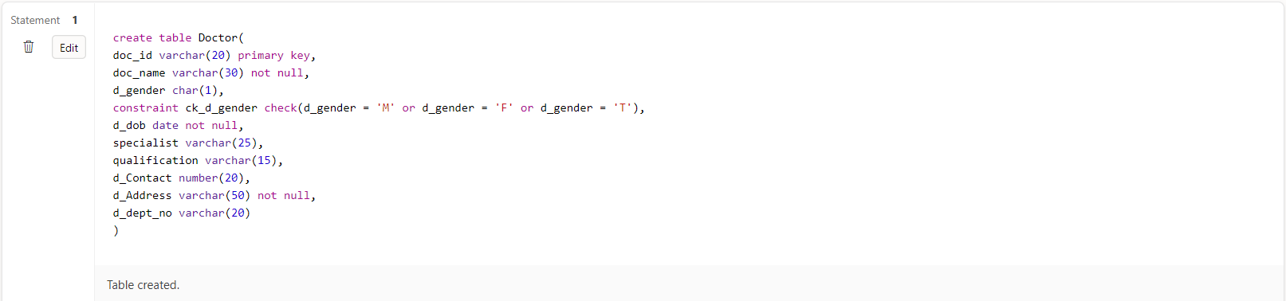

Department:
create table Department(
dept_no varchar(20) primary key,
dept_name varchar(30) not null,
room_no varchar(10),
floor number(5),
hod varchar(20),
constraint fk_hod foreign key(hod) references Doctor(doc_id),
estd_date date
) 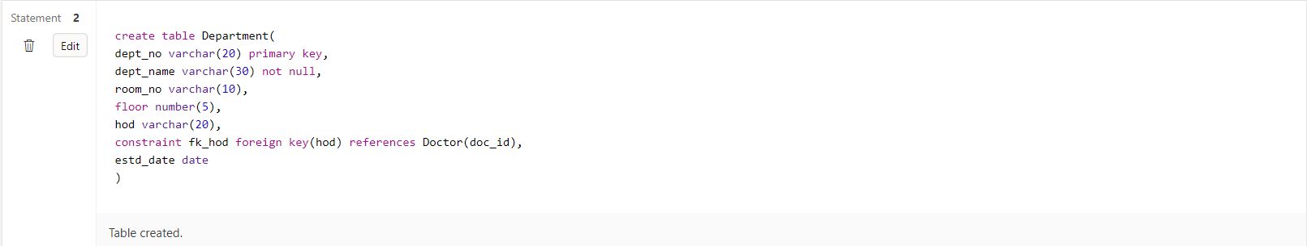

Staff:
create table Staff(
staff_id varchar(15) primary key,
staff_name varchar(25) not null,
category varchar(20),
designation varchar(15) not null,
s_dob date not null,
s_contact number(15),
s_address varchar(50),
s_dept_no varchar(10),
constraint fk_s_dept_no foreign key(s_dept_no) references Department(dept_no)
)
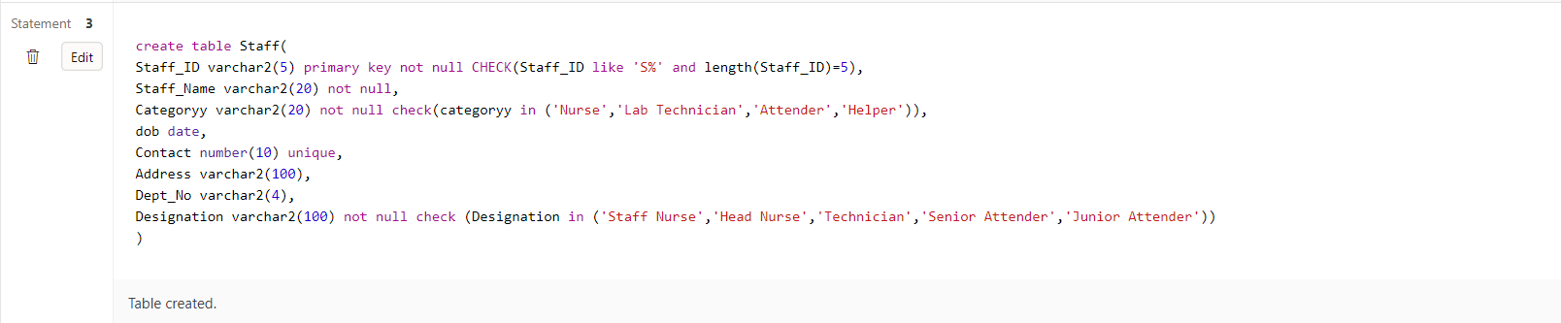
Patient:
create table Patient(
pat_id varchar(20) primary key,
pat_name varchar(30) not null,
p_dob date not null,
p_gender varchar(10) not null,
constraint ck_p_gender check(p_gender = 'M'or p_gender = 'F' or p_gender ='T'),
p_contact number(20),
p_address varchar(50) not null
)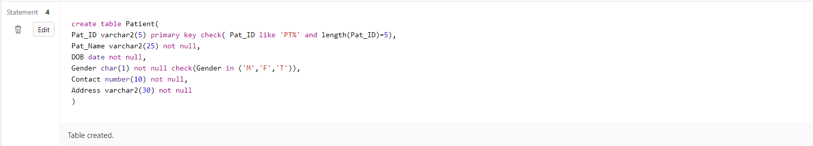

In_Patient:
create table In_Patient(
ip_id varchar(20),
doa date not null,
primary key(ip_id,doa),
bed_no varchar(10),
start_time date,
end_time date,
constraint fk_ip_id foreign key (ip_id) references Patient(pat_id)
)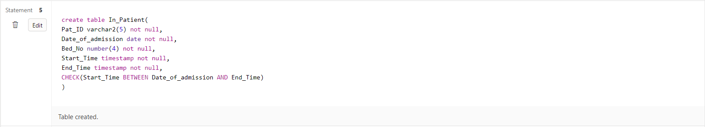

In_Patient_Prescription:
create table In_Patient_Prescription(
in_pat_id varchar(20) not null,
ip_pres_id varchar(20) not null,
primary key(in_pat_id,ip_pres_id),
constraint fk_pres_id foreign key(ip_pres_id) references Prescription(pres_id),
constraint fk_in_pat_id foreign key(in_pat_id) references Patient(pat_id)
)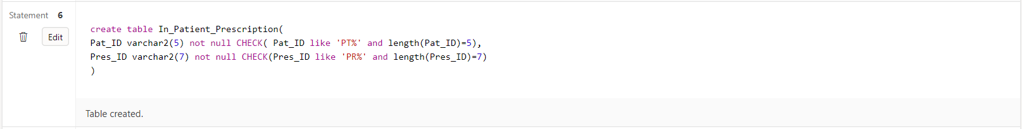

Appointment:
create table Appointment(
app_id varchar(20) primary key,
a_pat_id varchar(20),
constraint fk_a_pat_id foreign key(a_pat_id) references Patient(pat_id),
a_doc_id varchar(20),
constraint fk_a_doc_id foreign key(a_doc_id) references Doctor(doc_id),
nurse_id varchar(20),
constraint fk_nurse_id foreign key(nurse_id) references Staff(staff_id),
consult_room_no number(20),
a_date date not null,
a_time varchar(10) not null
)
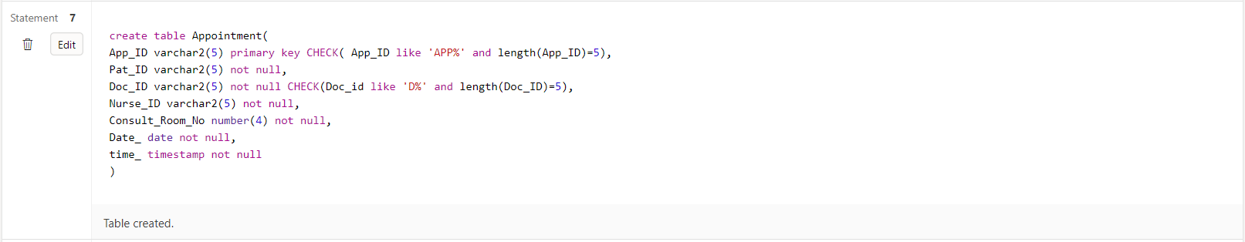

Prescription:
create table Prescription(
pres_id varchar(15) primary key,
p_app_id varchar(20),
constraint fk_p_app_id foreign key(p_app_id) references Appointment(app_id),
pres_date date not null,
pres_time varchar(10),
diagnosis_details varchar(20)
)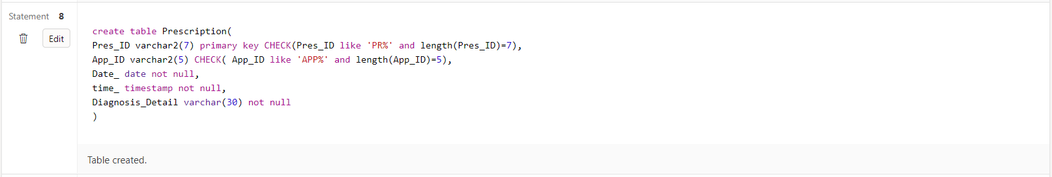

Prescribed_Medicines:
create table Prescribed_Medicines(
m_pres_id varchar(25) ,
constraint fk_m_pres_id foreign key (m_pres_id) references Prescription(pres_id),
medicine_name varchar(40) not null,
primary key(m_pres_id,medicine_name),
dosage varchar(20),
brand varchar(10)
)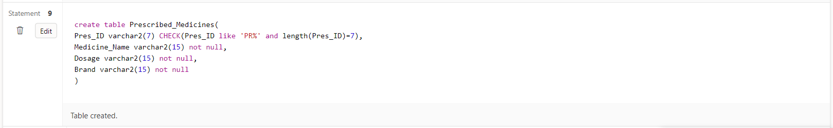

Hospital_Bill:
create table Hospital_Bill(
inv_no number(20),
inv_date date not null,
primary key(inv_no,inv_date),
i_pat_id varchar(20),
constraint fk_i_pat_id foreign key(i_pat_id) references Patient(pat_id),
bill_amount number(25),
payment_type varchar(25) not null,
discount number(20)
)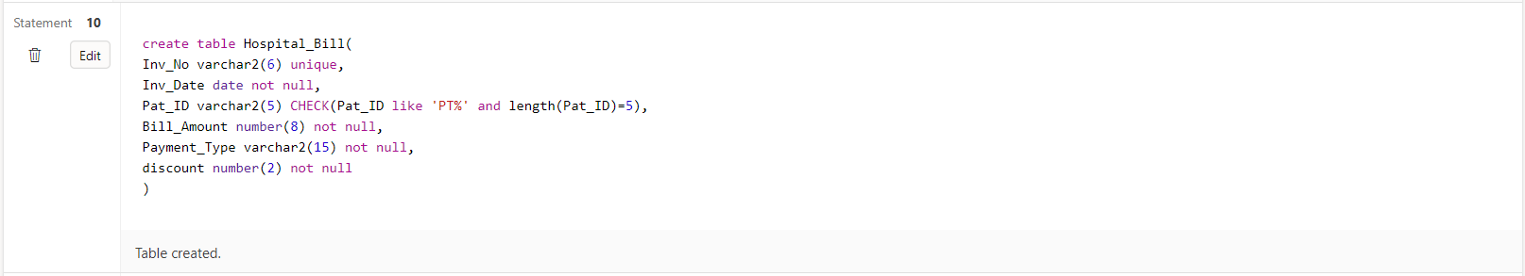

Lab_Tests:
create table Lab_Tests(
test_id varchar(20) primary key,
L_pat_id varchar(20),
constraint fk_L_pat_id foreign key(L_pat_id) references Patient(pat_id),
lab_date date,
lab_time varchar(10)
)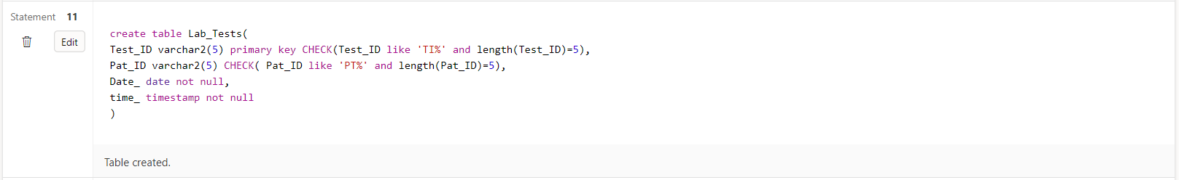

Test_Results:
create table Test_Results(
r_test_id varchar(20) ,
constraint fk_r_test_id foreign key (r_test_id) references Lab_Tests(test_id),
r_test_type_id varchar(20),
constraint fk_r_test_type_id foreign key(r_test_type_id) references test_types(tt_id),
primary key(r_test_id,r_test_type_id),
results varchar(20) not null
)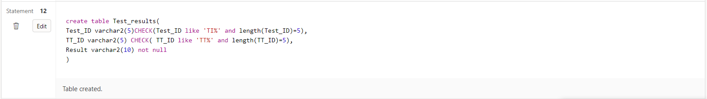

Test_Types:
create table test_types(
tt_id varchar(20) primary key,
description varchar(30),
low_value number(25),
high_value number(25),
test_method varchar(25),
technician varchar(20),
constraint fk_technician foreign key(technician) references Staff(staff_id)
)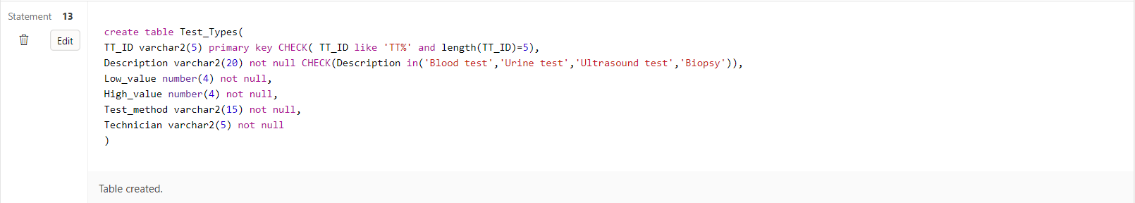

SCHEMA:

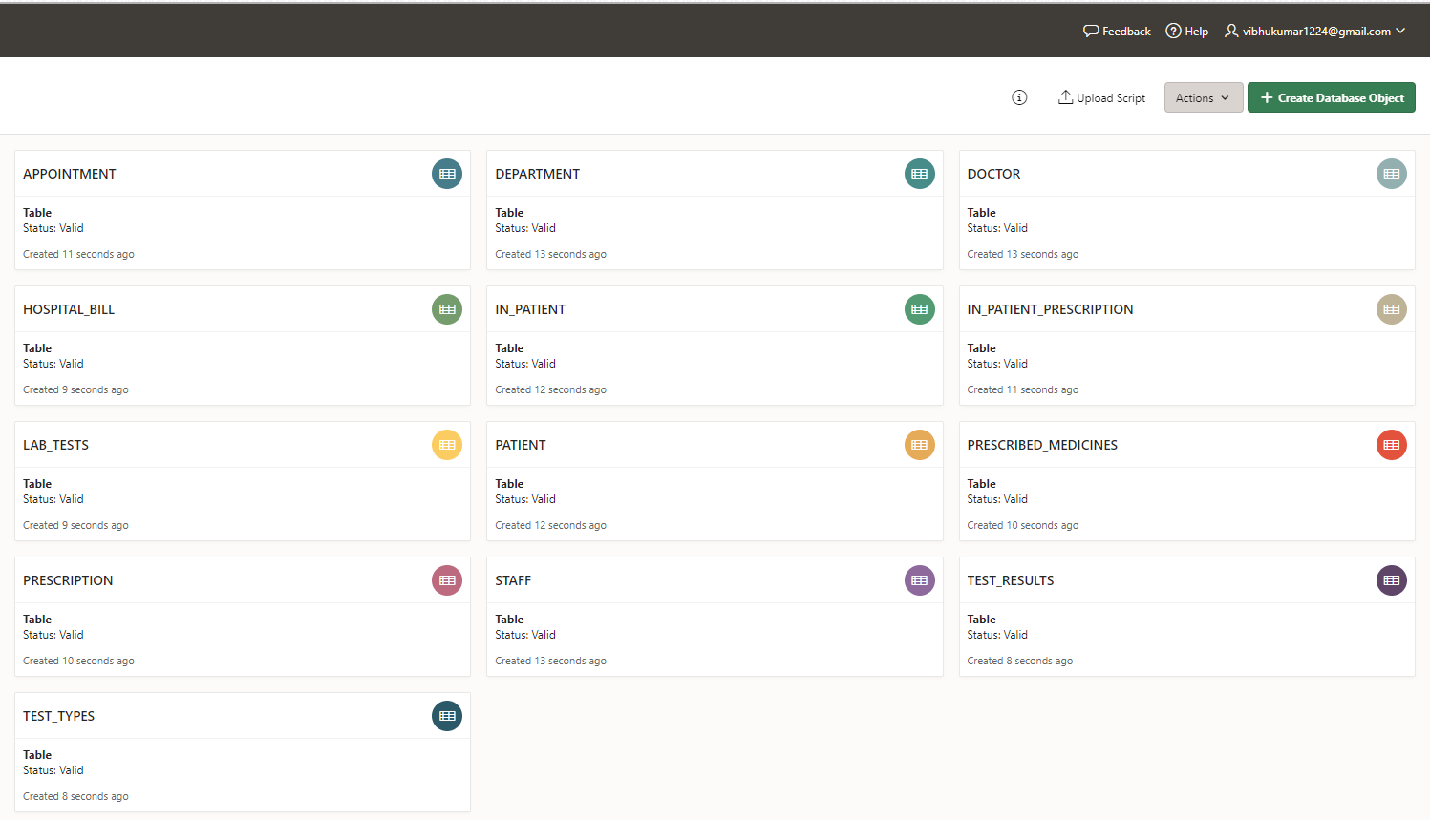

Inserting Values:
Doctor:
insert into Doctor values('D108','Vibhu Kumar','M','20-SEPTEMBER
1985','CARDIOLOGIST','MBBS',9926519823,'1,BAREILLY','D101');
insert into Doctor values('D105','Bhavya Singh','M','12-FEBRUARY-1980','NEUROLOGIST','BAMS',9254376189,'15,LUCKNOW','D103');
insert into Doctor values('D101','Sanjay Kumar','F','21-AUGUST-1989','NEPHROLOGIST','MD',976124512,'51,KANPUR','D101');
insert into Doctor values('D107','Aman Singh','M','01-JANUARY-1992','ONCOLOGIST','MD',8449268172,'95,AGRA','D190');
insert into Doctor values('D104','Paman Singh','M','21-DECEMBER-1991','GENERALMEDICINE','MD',8912678219,'102,PUNE','D101');
insert into Doctor values('D102','Tani Kaur','F','25-JUNE-1990','CARDIOLOGIST','MBBS',9363981256,'530,DELHI','D100');
insert into Doctor values('D106','Raghavan','M','03-FEBRUARY-1994','NEPHROLOGIST','MDS',9897268266,'17,MATHURA','D101');
insert into Doctor values('D103','Riya Patel','F','25-APRIL-1984','CARDIOLOGIST','MD',7904226737,'121,GWALIOR','D005');

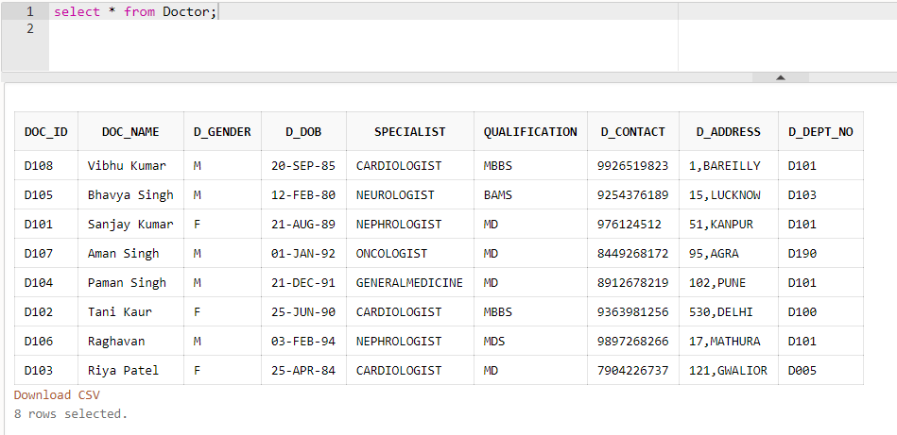
Department:
insert into Department values('D101','CARDIOLOGY','A-111',7,'D108','20-MARCH-2012');
insert into Department values('D103','NEUROLOGY','A-120',5,'D101','10-JANUARY-2011');
insert into Department values('D190','ONCOLOGY','A-005',9,'D105','19-DECEMBER-2019');
insert into Department values('D100','CARDIOLOGY','C-050',7,'D106','21-APRIL-2019');
insert into Department values('D005','GM','D-110',7,'D104','31-DECEMBER-2011');

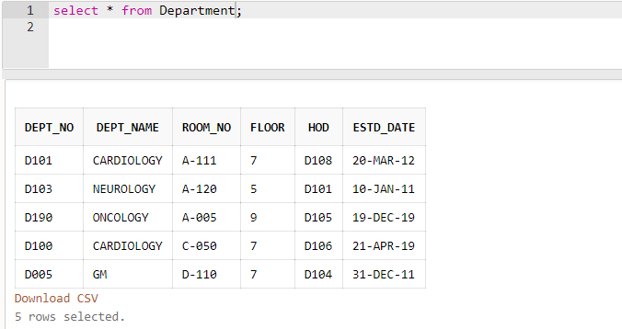

Staff:
insert into Staff values('S0001','Kirti','nurse','staff nurse','18-AUGUST-1998',9421862561,'BAREILLY','D101');
insert into Staff values('S0002','Swati Gangwar','nurse','staff nurse','05-SEPTEMBER-1999',9721765571,'LUCKNOW','D103');
insert into Staff values('S0003','Shivani Maurya','nurse','staff nurse','10-JUNE-1995',9421862561,'AGRA','D005');
insert into Staff values('S0004','Virat Singh','lab technician','technician','15-APRIL-1997',978945121,'MATHURA','D190');
insert into Staff values('S0005','Rohit Kashyap','lab technician','technician','18-DECEMBER-1998',978951124,'PILIBHIT','D190');
insert into Staff values('S0006','Deepanshu Gupta','cashier','staff cashier','11-DECEMBER-1994',9421862561,'MUMBAI','D101');
insert into Staff values('S0008','Manoj Kumar','ward boy','ward boy','29-AUGUST-1992',9787862561,'DELHI','D103');
insert into Staff values('S0009','Yash Jaiswal','security','staff security','06-DECEMBER-1996',9421862561,'GURGAON','D005');

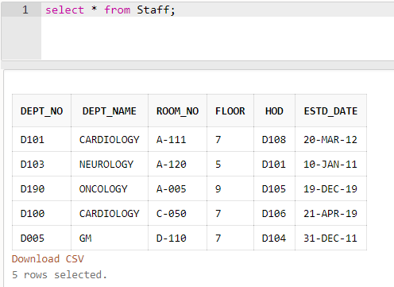

Patient:
insert into Patient values('P101','Vibhu Kumar','06-JULY-2000','M',9218357319,'52,BAREILLY');
insert into Patient values('P220','Tanuj','09-OCTOBER-1978','F',7841454511,'132,MUMBAI');
insert into Patient values('P103','Steve ','20-DECEMBER-1975','M',9751254454,'08,DELHI');
insert into Patient values('P104','Mani','15-JUNE-1995','M',944587122,'62,JHANSI');
insert into Patient values('P105','Fara Khan','19-DECEMBER-2014','F',9878987890,'12,GWALIOR');
insert into Patient values('P106','Gayle','25-MARCH-1990','M',944548412,'102,MATHURA');
insert into Patient values('P107','Mansi Jaiswal','07-JUNE-1994','F',9785458412,'190,BAREILLY');
insert into Patient values('P108','Karthik','21-AUGUST-1979','M',944548412,'06,KANPUR');

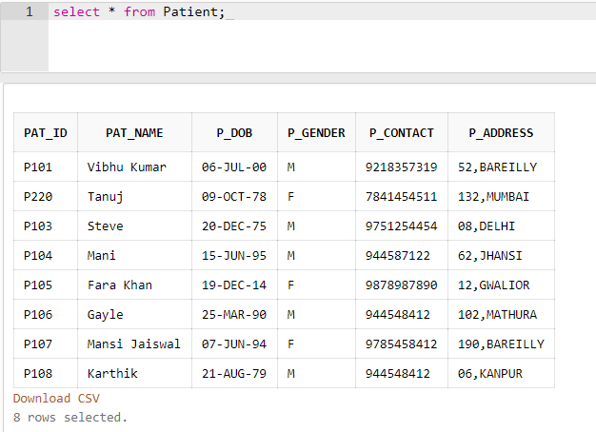

In_Patient:
insert into In_Patient values('P101', '11-MARCH-2017','B101','11-MARCH-2017','18-MARCH-2017');
insert into In_Patient values('P220', '10-JANUARY-2020' ,'B012','10-JANUARY-2020','30-JANUARY-2020');
insert into In_Patient values('P104', '28-FEBRUARY-2020' ,'B101','28-FEBRUARY-2020','15-MARCH-2020');
insert into In_Patient values('P105', '30-MARCH-2017','B015','30-MARCH-2017','09-APRIL-2017');
insert into In_Patient values('P106', '30-DECEMBER-2019','B001','30-DECEMBER-2019','15-JANUARY-2020');
insert into In_Patient values('P107','30-MARCH-2020','B019','30-MARCH-2020','17-APRIL-2020');
insert into In_Patient values('P103','29-MAY-2020','B101','29-MAY-2020','12-JUNE-2020');
insert into In_Patient values('P108','30-NOVEMBER-2019','B14','30-NOVEMBER-2019','30-DEC-2019');

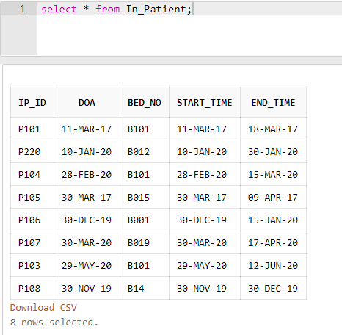
Appointment:
insert into Appointment values('A101','P101','D101','S0001',103,'12-MARCH-2017','13:00');
insert into Appointment values('A102','P220','D102','S0002',111,'11-JANUARY-2020','12:00');
insert into Appointment values('A103','P103','D103','S0003',100,'01-JANUARY-2020','17:00');
insert into Appointment values('A104','P104','D104','S0004',005,'18-FEBRUARY-2020','11:00');
insert into Appointment values('A105','P105','D105','S0005',120,'25-AUGUST-2019','08:00');
insert into Appointment values('A106','P106','D106','S0006',111,'01-MAY-2020','09:30');
insert into Appointment values('A107','P107','D107','S0008',111,'01-MAY-2020','10:15');
insert into Appointment values('A108','P108','D108','S0009',105,'01-MAY-2020','11:20');

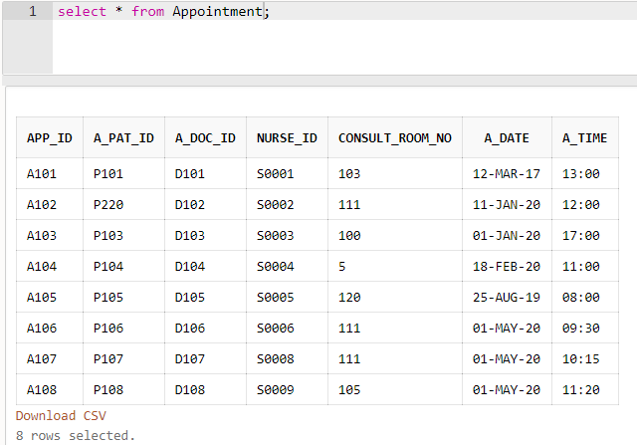

Precription:
insert into Prescription values('PR00001','A101', '12-MARCH-2017' ,'13:30','COUGH');
insert into Prescription values('PR00002','A102', '11-JANUARY-2020' ,'13:00','NEURAL ATTACK');
insert into Prescription values('PR00003','A103','02-JANUARY-2020','14:00','BILATERAL PNEUMONIA');
insert into Prescription values('PR00004','A104','18-FEBRUARY-2020','16:00','COUGH');
insert into Prescription values('PR00005','A105','25-AUGUST-2019','08:30','CARDIAC ARREST');
insert into Prescription values('PR00006','A106','01-MAY-2020','10:15','ACCIDENT');
insert into Prescription values('PR00007','A107','01-MAY-2020','11:25','COUGH');
insert into Prescription values('PR00008','A108','01-MAY-2020','12:30','CARDIAC ARREST');

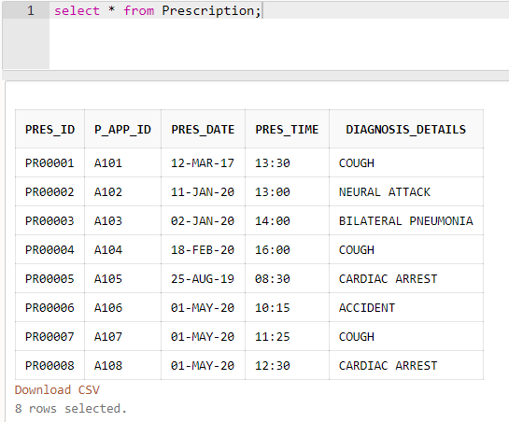
In_Patient_Prescription:
insert into In_Patient_Prescription values('P101','PR00001');
insert into In_Patient_Prescription values('P220','PR00002');
insert into In_Patient_Prescription values('P103','PR00003');
insert into In_Patient_Prescription values('P104','PR00004');
insert into In_Patient_Prescription values('P105','PR00005');
insert into In_Patient_Prescription values('P106','PR00006');
insert into In_Patient_Prescription values('P107','PR00007');
insert into In_Patient_Prescription values('P108','PR00008');

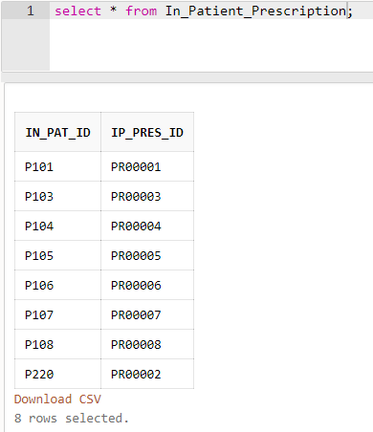

Prescribed_Medicines:
insert into Prescribed_Medicines values('PR00001','AMOXICILLIN','TWICE A DAY','Ranbaxy');
insert into Prescribed_Medicines values('PR00002','AMANTADINE','ONCE A DAY','DEF');
insert into Prescribed_Medicines values('PR00003','MACROLIDE','ONCE A DAY','Ranbaxy');
insert into Prescribed_Medicines values('PR00004','AMOXICILLIN','THRICE A DAY','XYZ');
insert into Prescribed_Medicines values('PR00005','LIDOCAINE','TWICE A DAY','JKL');
insert into Prescribed_Medicines values('PR00006','TYLENOL','ONCE A DAY','MNO');
insert into Prescribed_Medicines values('PR00007','AMOXICILLIN','THRICE A DAY','PQR');
insert into Prescribed_Medicines values('PR00008','LIDOCAINE','TWICE A DAY','Ranbaxy');
insert into Hospital_Bill values(1020,'18-MARCH-2017','P101',10000,'CASH',12);

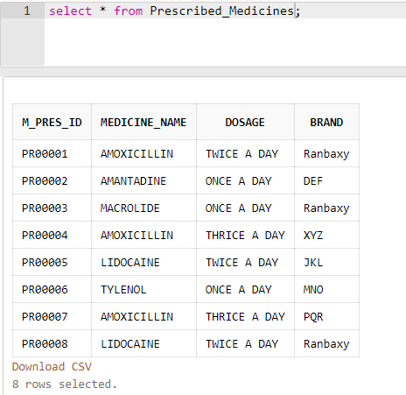
Hospital_Bill:
insert into Hospital_Bill values(1021,'30-JANUARY-2020','P220',200000,'CREDIT CARD',15);
insert into Hospital_Bill values(1022,'30-MAY-2020','P103',11000,'DEBIT CARD',20);
insert into Hospital_Bill values(1023,'28-FEBRUARY-2020','P104',15000,'DEBIT CARD',13);
insert into Hospital_Bill values(1024,'30-JANUARY-2020','P105',20000,'CREDIT CARD',05);
insert into Hospital_Bill values(1025,'09-APRIL-2017','P106',7000,'CASH',22);
insert into Hospital_Bill values(1026,'17-APRIL-2020','P107',3500,'CASH',18);
insert into Hospital_Bill values(1027,'12-JUNE-2020','P108',42000,'DEBIT CARD',10);
insert into Hospital_Bill values(1028,'05-JUNE-2020','P103',2000,'DEBIT CARD',21);
insert into Hospital_Bill values(1029,'09-JUNE-2020','P103',15000,'DEBIT CARD',20);

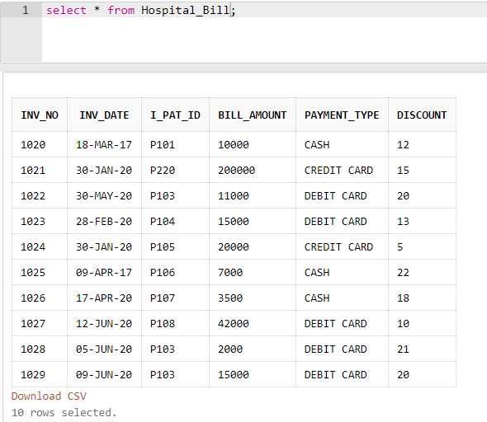

Lab_Tests:
insert into Lab_Tests values('T0001','P101','13-MARCH-2017','11:00');
insert into Lab_Tests values('T0002','P220','12-JANUARY-2020','09:00');
insert into Lab_Tests values('T0003','P103','03-JANUARY-2020','10:00');
insert into Lab_Tests values('T0004','P104','19-FEBRUARY-2020','09:30');
insert into Lab_Tests values('T0005','P105','26-AUGUST-2019','16:00');
insert into Lab_Tests values('T0006','P106','02-MAY-2020','17:00');
insert into Lab_Tests values('T0007','P107','03-MAY-2020','13:00');
insert into Lab_Tests values('T0008','P108','03-MAY-2020','14:00');

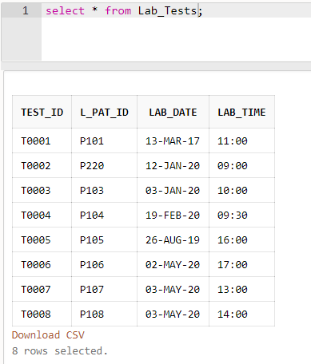
Test_Types:
insert into test_types values('TT0001','URINE TEST',26,74,'LAB','S0001');
insert into test_types values('TT0002','CT',15,20,'LAB','S0002');
insert into test_types values('TT0003','Blood Sugar Level',18,28,'LAB','S0003');
insert into test_types values('TT0004','XRAY TEST',38,52,'LAB','S0001');
insert into test_types values('TT0005','CT TEST',12.5,14.2,'LAB','S0005');
insert into test_types values('TT0006','URINE TEST',12,22,'LAB','S0001');
insert into test_types values('TT0007','XRAY',19,29,'LAB','S0009');
insert into test_types values('TT0008','Blood Glucose Level',2,10,'LAB','S0008');

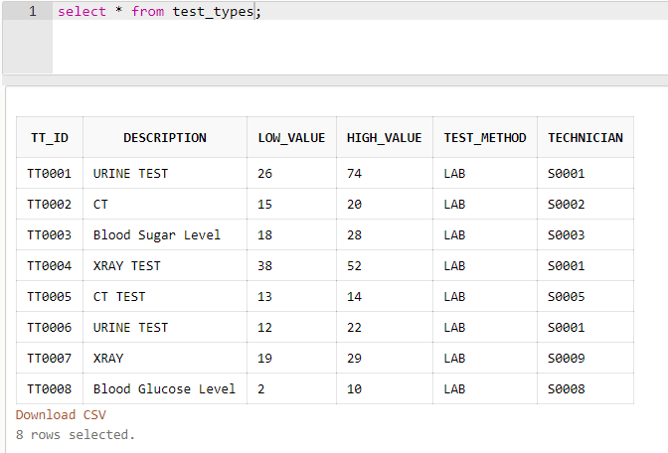

Test_Results:
insert into Test_Results values('T0001','TT0001','POSITIVE');
insert into Test_Results values('T0002','TT0002','NEGATIVE');
insert into Test_Results values('T0003','TT0003','NEGATIVE');
insert into Test_Results values('T0004','TT0004','POSITIVE');
insert into Test_Results values('T0005','TT0005','NEGATIVE');
insert into Test_Results values('T0006','TT0006','NEGATIVE');
insert into Test_Results values('T0007','TT0007','POSITIVE');
insert into Test_Results values('T0008','TT0008','NEGATIVE');

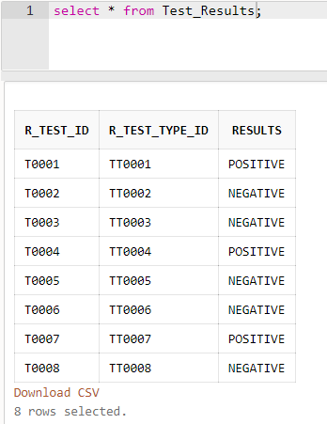
Questions:
DDL statements (ALTER, CONSTRAINT etc):

Q1. Modify Hospital_Bill by adding an attribute consulting_physician and add
foreign key constraint for that attribute. Use constraint name for foreign key
constraint.
A1.
alter table Hospital_Bill add consulting_physician varchar(15);
alter table Hospital_Bill add constraint fk_con_physician foreign key(consulting_physician) references Doctor(doc_id);
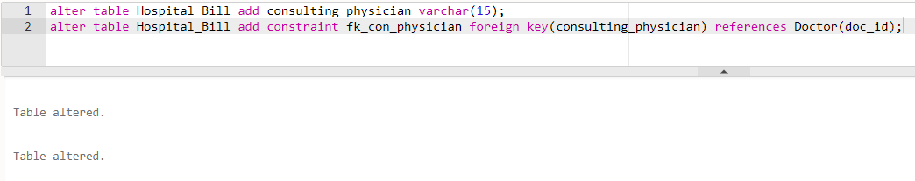

Q2. In Patient table, replace address with three attributes namely street, city and
pincode.
A2.
alter table Patient drop column p_address;
alter table Patient add street varchar(20);
alter table Patient add city varchar(15);
alter table Patient add pincode number(6);

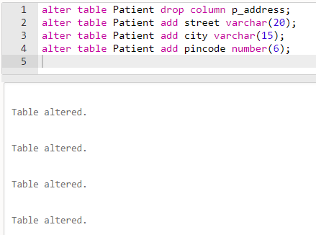

Q3. Add an attribute Test_Time which can accept only two values “Before food”
and “After food” with proper constraint name.
A3.
alter table Patient add Test_Time varchar(10);
alter table Patient add constraint ck_test_time check(Test_Time = 'Before food' or Test_Time = 'After food');

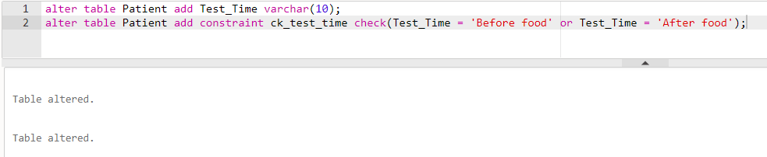

Q4. Remove the constraint only from test_time attribute.
A4.
alter table Patient drop constraint ck_test_time;

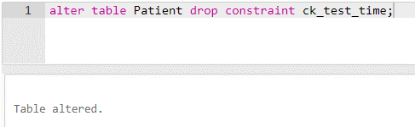

Q5. Drop address attribute from staff table and add attributes door_no, street,
city, and pincode.
A5.
alter table Staff drop column s_address;
alter table Staff add door_no number(5);
alter table Staff add street varchar(15);
alter table Staff add city varchar(15);
alter table Staff add pincode number(6);

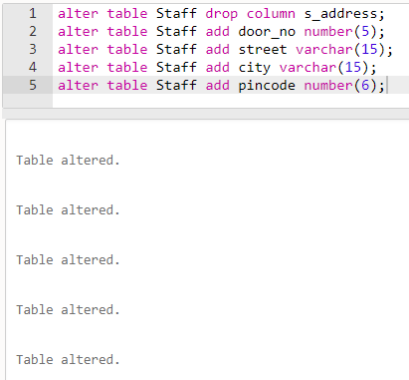

6. Create a table Medicines with schema medicines=(med_name, brand,
dosage, manu_date, exp_date). Ensure that manu_date should not be later
than exp_date. Create an appropriate constraint to ensure this.
A6.
create table Medicines(
med_name varchar(30),
brand varchar(20),
primary key(med_name),
dosage varchar(25),
manu_date date,
exp_date date,
constraint ck_manu_date check(manu_date < exp_date)
);

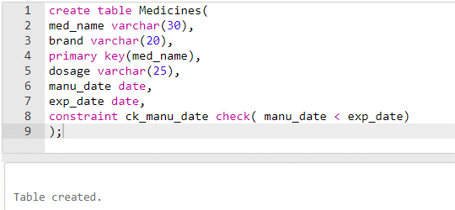

Q7. Remove the attributes dosage and brand from Prescribed_Medicines and
alter the medicine_name attribute as a foreign key referencing the new table
Medicines.
A7.
alter table Prescribed_Medicines drop column dosage;
alter table Prescribed_Medicines drop column brand;
alter table Prescribed_Medicines add constraint fk_medicine_name foreign key(medicine_name) references Medicines(med_name);

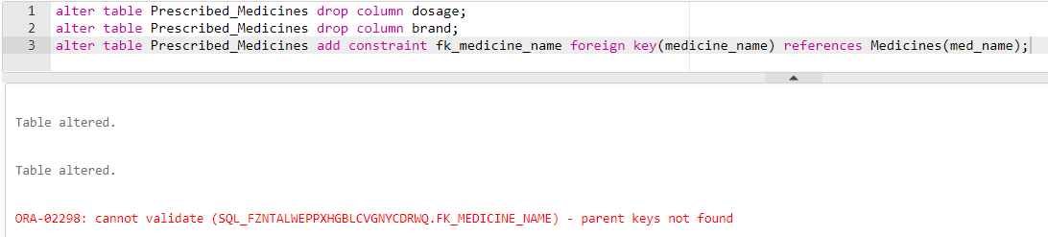

Error because there is no current values in the table Medicines.

Q8. Create a view for doctors who are specialized in ‘Cardiology’ from Doctor
table with attributes doc_id, doc_name and gender.
A8.
create view Cardiology_Doctors as select doc_id, doc_name, d_gender from Doctor where specialist = 'Cardiology';

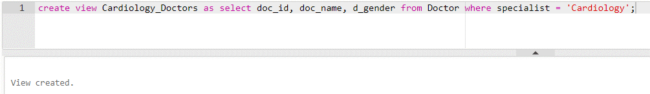

Q9. Add an attribute No_of_staff in Department table and create a constraint
with constraint name to make sure the number is >0.
A9.
alter table Department add No_of_staff int;
alter table Department add constraint ck_no_of_staff check(No_of_staff > 0);
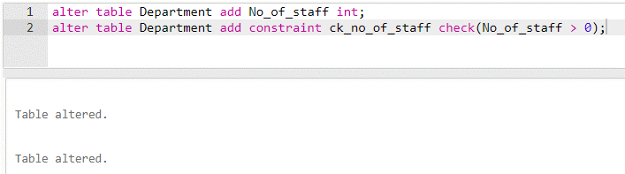

Q10. Add an attribute with In_Patient_prescription to store the Room_Type
which can store the values “AC” and “Non-AC”.
A10.
alter table In_Patient_Prescription add Room_Type varchar(8);
alter table In_Patient_Prescription add constraint ck_Room_Type check(Room_Type = 'AC' or Room_Type = 'Non-AC');

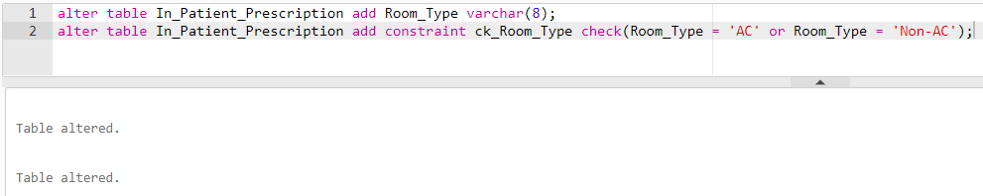

SQL queries with JOIN operation
(Practice these queries with Cartesian product,
inner join, natural join etc.)

Q1. Find the HOD of doctor ‘Raghavan’ (Hint: you need to join the tables
DOCTOR and DEPARTMENT)
A1.
Using cartesian Product:
select hod from Department, Doctor where Department.dept_no = Doctor.d_dept_no and doc_name = 'Raghavan';

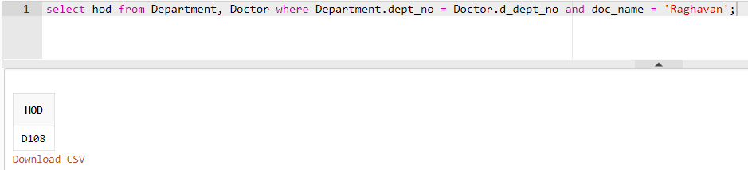

Using Inner Join:

select h.hod from Department h inner join Doctor d on d.d_dept_no = h.dept_no where d.doc_name = 'Raghavan';
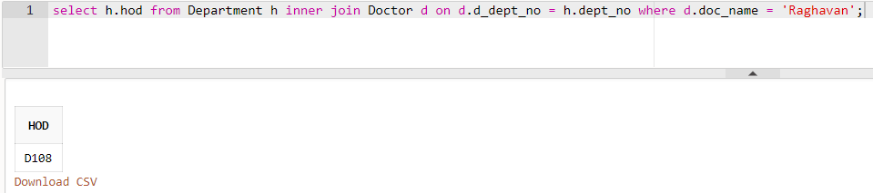

Q2. Find the list of all patients who were admitted in bed number ‘B101’.
A2.
Using Cartesian Product:
select pat_name from Patient,In_Patient where Patient.pat_id = In_Patient.ip_id and bed_no = 'B101';

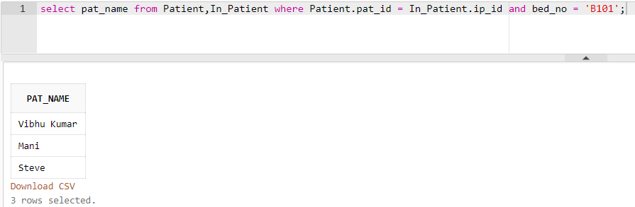

Using Inner Join:
select distinct p.pat_name from Patient p inner join In_Patient i on p.pat_id = i.ip_id and i.bed_no = 'B101';

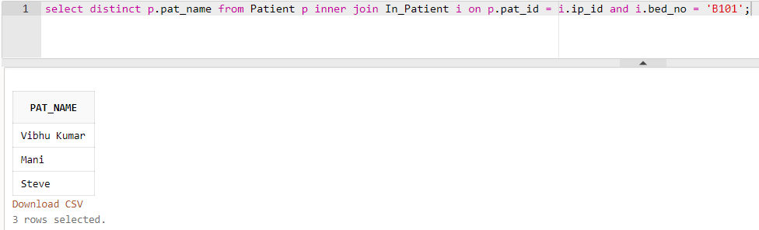

Q3. Display all the prescribed medicines of patient with Pat_ID ‘P101’.
A3.
select distinct medicine_name from Prescribed_Medicines,Patient where Patient.pat_id = 'P101';

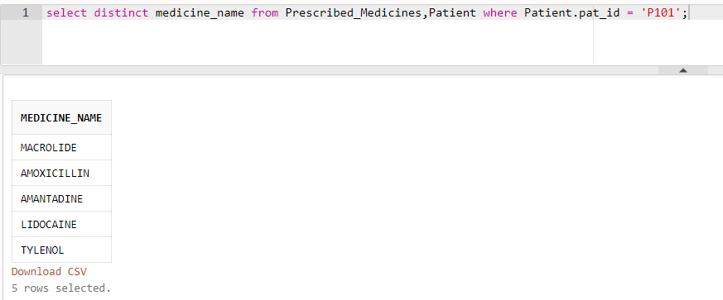

Q4. Display the test results of patient ‘Mani’.
A4.
select results from Test_Results, Lab_Tests,Patient where Test_Results.r_test_id = Lab_Tests.test_id and Lab_Tests.l_pat_id = Patient.pat_id and pat_name = 'Mani';

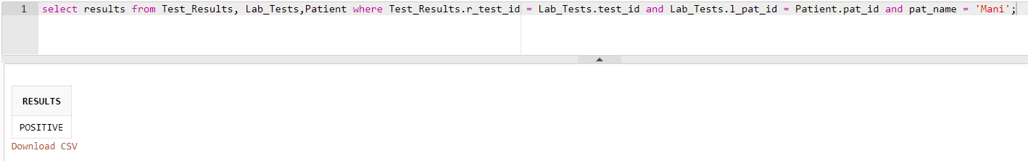

Q5. Display all bills of bill amount more than 10000 rupees and paid by the
patient ‘Steve’.
A5.
select distinct b.bill_amount from Hospital_Bill b inner join Patient p on b.i_pat_id = 'P103' where b.bill_amount > 10000;

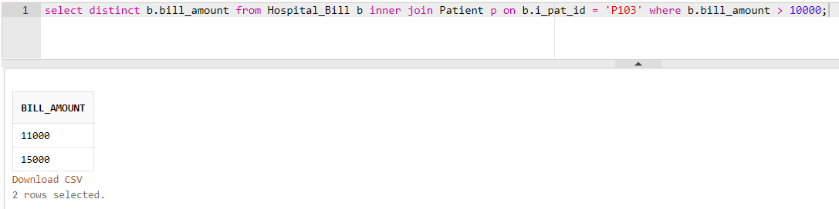

Q6. Find the category and address of the nurse who attended the patient with
pat_no ‘P220’.
A6.
Using Cartesian Product:

select category,s_address from Staff,Appointment
where Staff.staff_id = Appointment.nurse_id and Appointment.a_pat_id = 'P220';

Using Inner Join:

select s.category, s.s_address from Staff s inner join Appointment a on s.staff_id = a.nurse_id where a.a_pat_id = 'P220';

Q7. Find the list of doctors who worked in the department which is started on or
after ’10-May-2018’.
A7.
Using Cartesian Product:

select doc_name from Doctor,Department where Doctor.d_dept_no = Department.dept_no and estd_date >= '10-May-2018';

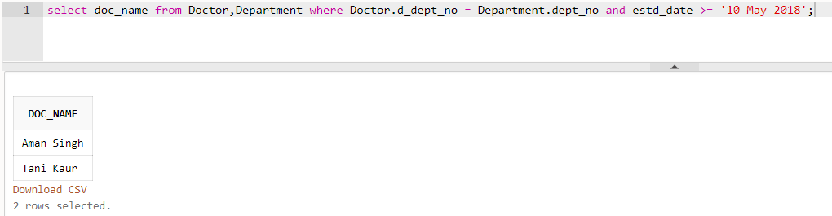

Using Inner Join:

select d.doc_name from Doctor d inner join Department w on d.d_dept_no = w.dept_no where w.estd_date >= '10-May-2018';

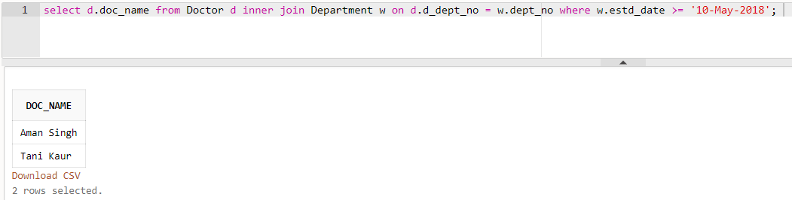

Q8. Get the name of technicians who tests blood glucose level.
A8.
Using Cartesian Product:

select staff_name from Staff,test_types
where test_types.technician = Staff.staff_id and description = 'Blood Glucose Level';

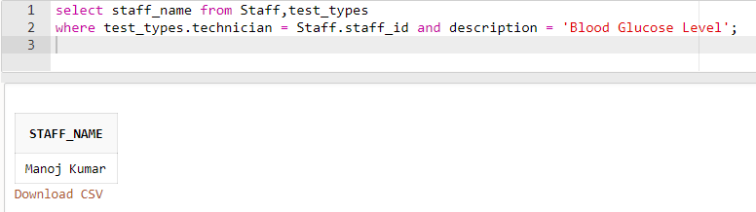

Using Inner Join:

select n.staff_name from Staff n inner join test_types t on t.technician = n.staff_id where t.description = 'Blood Glucose Level';
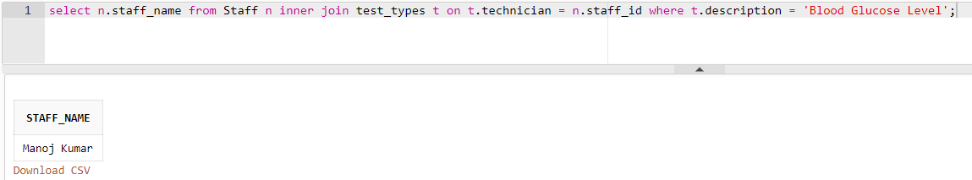

Q9. Display the details of all patients who were hospitalized between ’10-Mar-
2017’ and ’10-Apr-2017’.
A9.
Select distinct *from In_Patient s, In_Patient e where s.doa > '10-Mar2017' and e.doa < '10-April-2017';

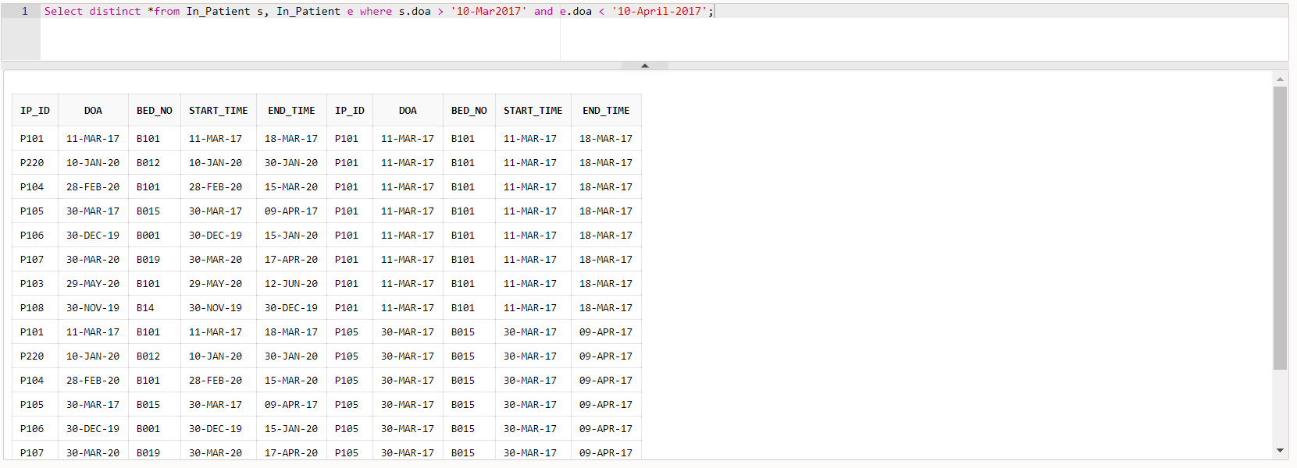

Q10. Display the in-patient prescription of the patient whose name is ‘Gayle’.
A10.
Using Cartesian Product:

select *from In_Patient_Prescription,Patient where In_Patient_Prescription.in_pat_id = Patient.pat_id and pat_name = 'Gayle';

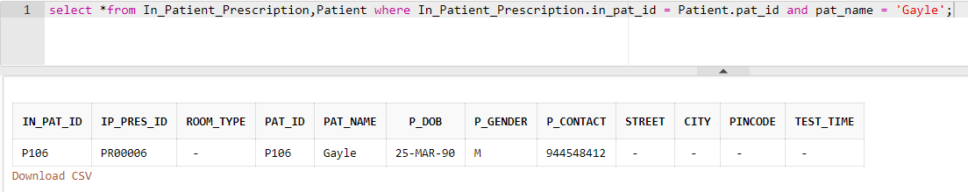

Using Inner Join

select *from In_Patient_Prescription i inner join Patient p on i.in_pat_id = p.pat_id where p.pat_name = 'Gayle';
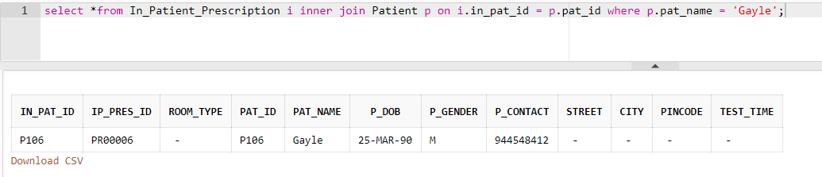

SQL queries with AGGREGATE and CHAR functions

Q1. Find the number of doctors who are working in the department ‘D101’.
A1.
select count(*) as D101_Count from Doctor where d_dept_no = 'D101';

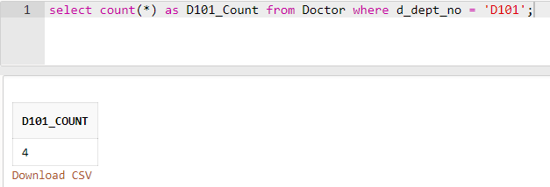

Q2. Count the number of male patients who are treated by the doctor with doctor
id ‘D101’.
A2.
select count(p.p_gender) as male_patient_count from Patient,Appointment where Appointment.a_pat_id = Patient.pat_id and Appointment.a_doc_id = 'D101';

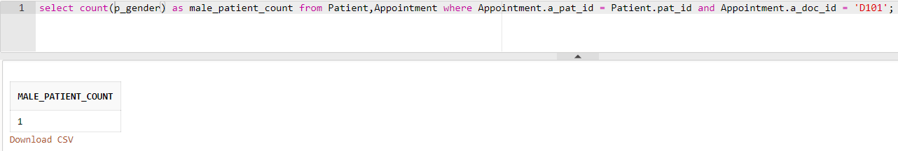

Q3. Find the total bill paid by the patient ‘Karthik’.
A3.
select sum(Hospital_Bill.bill_amount) as total_bill_paid_by_karthik from Hospital_Bill,Patient where Hospital_Bill.i_pat_id = Patient.pat_id and pat_name = 'Karthik';

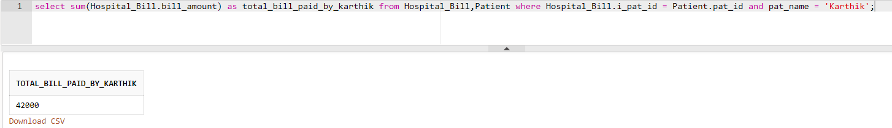

Q4. Find the name and address of the patient who paid the highest bill of all
patients.
A4.
select pat_name,p_address from Patient,Hospital_Bill where Patient.pat_id = Hospital_Bill.i_pat_id and Hospital_Bill.bill_amount = (select max(bill_amount) from Hospital_Bill);

Q5. Get the specialization of doctors whose name start with the letter ‘M’.
A5.
select specialist,doc_name from Doctor where doc_name like 'M%';

Q6. Find the all the patients details whose name is exactly 5 characters long.
A6.
select *from Patient where pat_name like '_____';

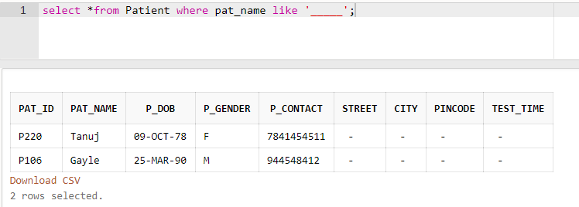
Q7. Display the department names in ascending order.
A7.
select dept_name from Department order by dept_name asc;

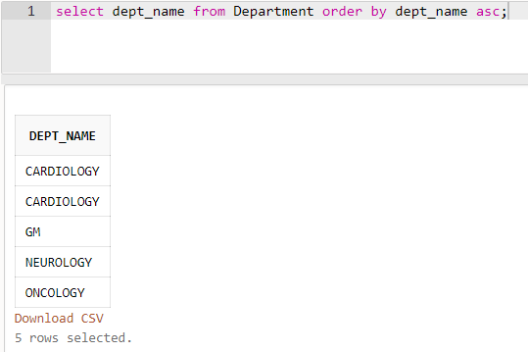

Q8. Get the gender wise count of patients.
A8.
select count(p_gender ) as male_count from Patient where p_gender = 'M';
select count(p_gender) as female_count from Patient where p_gender = 'F';
select count(p_gender) as third_gender from Patient where p_gender = 'T';

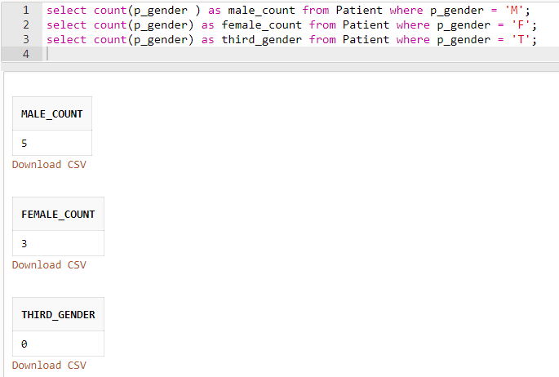

Q9. Get the count of doctors for each specialization.
A9.
select count(specialist) as cardiologist_count from Doctor where specialist = 'CARDIOLOGIST';
select count(specialist) as neurologist_count from Doctor where specialist = 'NEUROLOGIST';
select count(specialist) as nephrologist_count from Doctor where specialist = 'NEPHROLOGIST';
select count(specialist) as oncologist_count from Doctor where specialist = 'ONCOLOGIST';
select count(specialist) as generalmedicine_count from Doctor where specialist = 'GENERALMEDICINE';

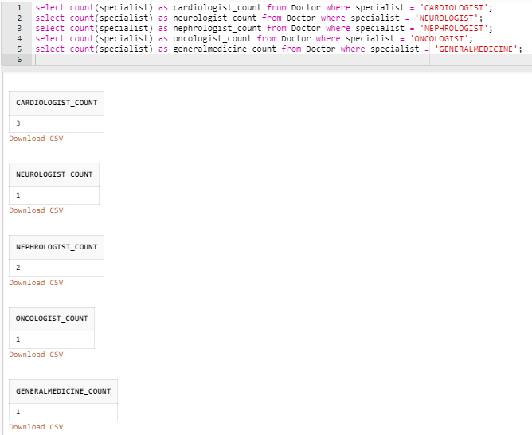

Q10. Get the total number tests conducted in any particular date.
A10.
select count(l_pat_id) from Lab_Tests where lab_date = '03-MAY-2020';

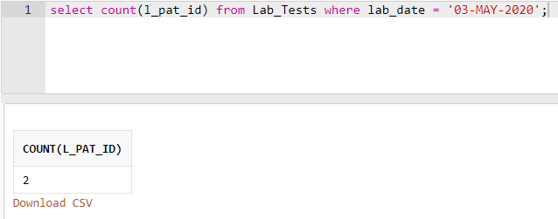

SQL queries - Nested subqueries

Q1. All of the queries in “SQL queries with JOIN operation” section can be tried
with subqueries concept.
A1.
(a). Find the HOD of doctor ‘Raghavan’ (Hint: you need to join the tables DOCTOR and DEPARTMENT)
select hod from Department where dept_no = (select d_dept_no from Doctor where doc_name = 'Raghavan');

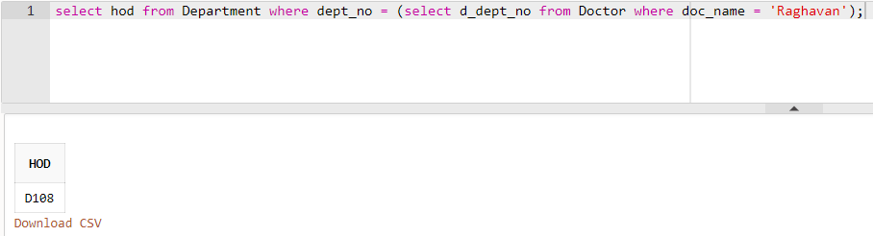

(b). Find the list of all patients who were admitted in bed number ‘B101’.
select pat_name from Patient where pat_id in (select ip_id from In_Patient where bed_no = 'B101');

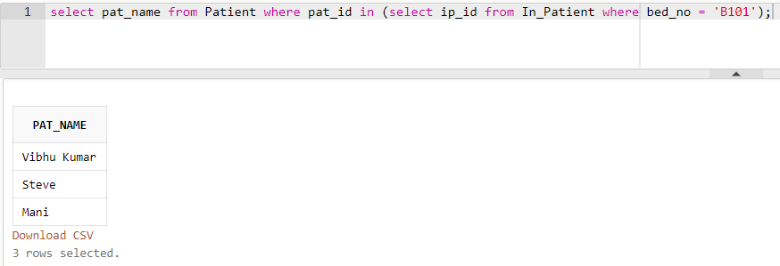

(c). Display all the prescribed medicines of patient with Pat_ID ‘P101’.
select medicine_name from Prescribed_Medicines where m_pres_id in (select ip_pres_id from In_Patient_Prescription where in_pat_id = 'P101');

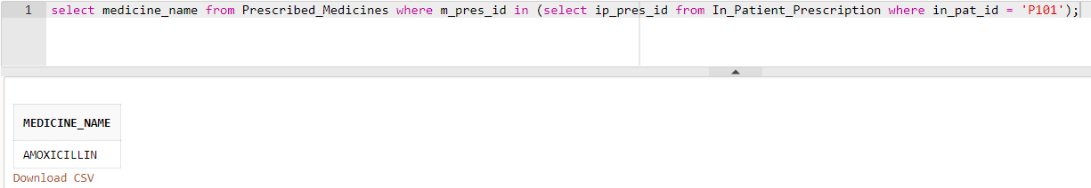

(d). Display the test results of patient ‘Mani’.
select results from Test_Results where r_test_id = (select test_id from Lab_Tests ,Patient where Lab_Tests.l_pat_id = Patient.pat_id and pat_name = 'Mani');

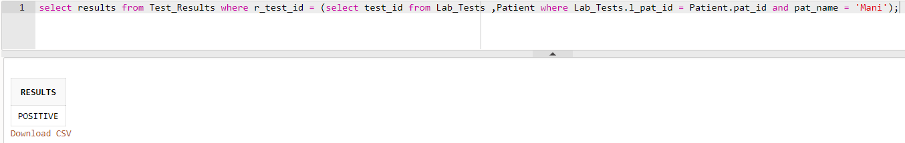

(e). Display all bills of bill amount more than 10000 rupees and paid by the patient ‘Steve’.
select bill_amount from Hospital_Bill where i_pat_id = (select pat_id from Patient where pat_name = 'Steve') and bill_amount > 10000;

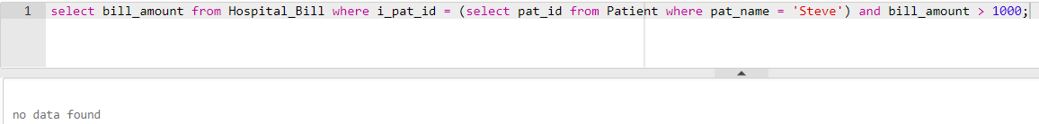

(f). Find the category and address of the nurse who attended the patient with pat_no ‘P220’.
select category, s_address from Staff where staff_id in (select nurse_id from Appointment where a_pat_id = 'P220');

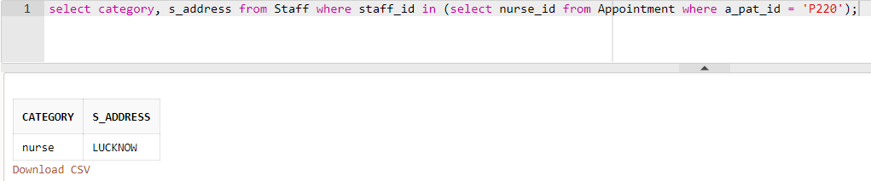

(g). Find the list of doctors who worked in the department which is started on or after ’10-May-2018’.
select doc_id, doc_name from Doctor where d_dept_no in (select dept_no from Department where estd_date >= '10-MAY-2018');

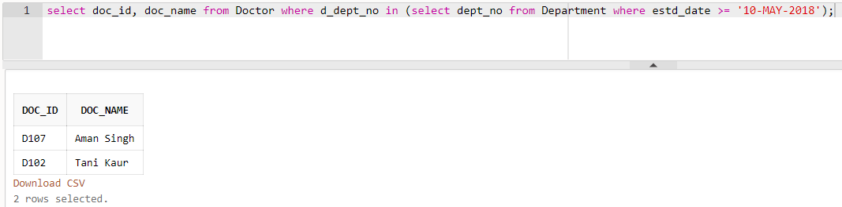

(h). Get the name of technicians who tests blood glucose level.
select staff_name from Staff where staff_id = (select technician from test_types where description = 'Blood Glucose Level');

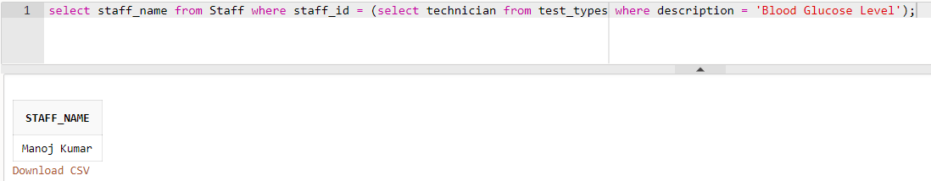

(i). Display the details of all patients who were hospitalized between ’10-Mar2017’ and ’10-Apr-2017’
select *from Patient where pat_id in (select ip_id from In_Patient where start_time > '10-MARCH-2017' and end_time < '10-APRIL-2017');

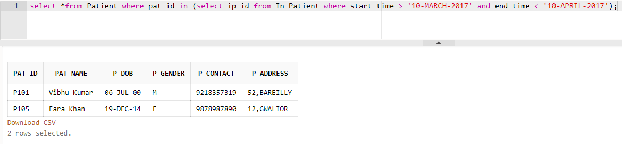

(j). Display the in-patient prescription of the patient whose name is ‘Gayle’.
select *from In_Patient_Prescription where in_pat_id = (select pat_id from Patient where pat_name = 'Gayle');

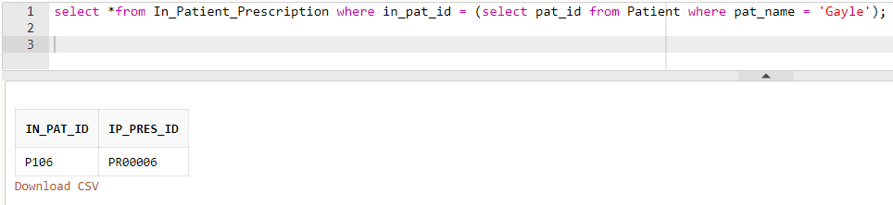

Q3. Find the name and id of all patients who are older than all the doctors in the
entire ‘cardiology’ department. Use subqueries and ALL operator.
A3.
select pat_name, pat_id from Patient where p_dob < all(select d_dob from Doctor where d_dept_no = 'D101' or d_dept_no = 'D100');

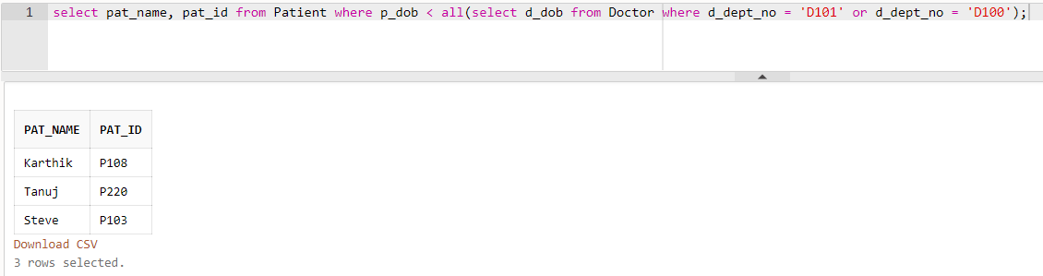
Q4. Find the prescription ids of all prescription that included a medicine from the
brand ‘Ranbaxy’ using nested subqueries.
A4.
select pres_id from Prescription where pres_id in (select m_pres_id from Prescribed_Medicines where brand = 'Ranbaxy');

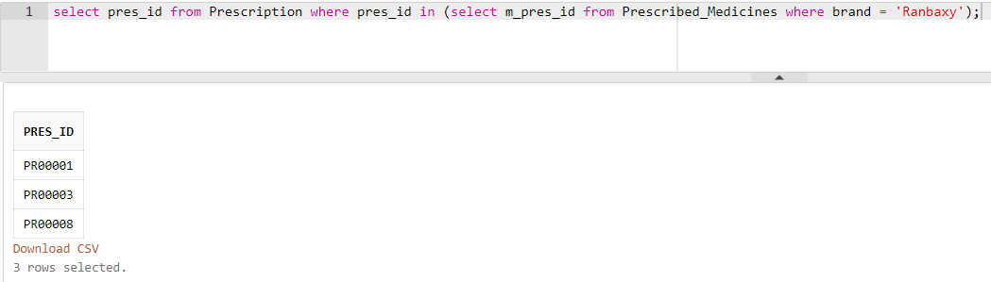

Q5. Find the list of patients who paid their bill through either ‘credit card’ or
‘debit card’ using subquery.
A5.
select pat_name from Patient where pat_id in (select i_pat_id from Hospital_Bill where payment_type = 'CREDIT CARD' or payment_type = 'DEBIT CARD');

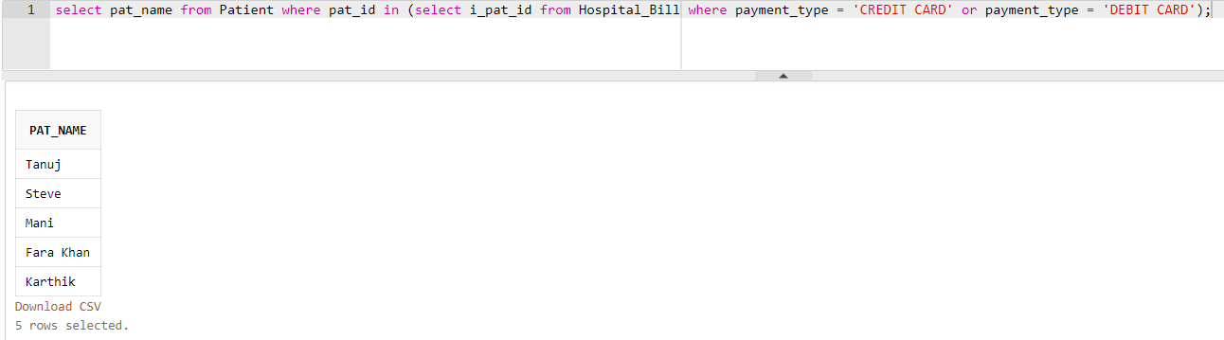

SQL queries using other functions

Practice queries using DATE, NUMERIC, and CHARACTER functions. Refer
DBMS_Lab_Reference_Material.pdf file. Try to upload at least two queries from
each function category.

Q1. Using DATE function.
A1.
- select * from Department where estd_date='20-Mar-12';

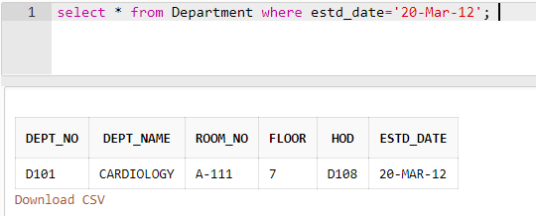

- select * from Doctor where d_dob>'25-JUN-90';

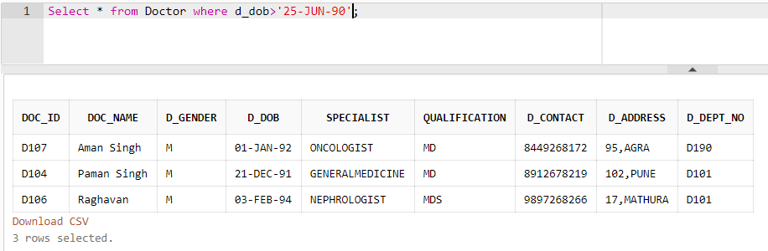

Q2. Using Numeric function.
A2.
- Find the Square root of Bill Amount of Patient having Patient ID as ‘P220’.

select sqrt(bill_amount) from Hospital_Bill where i_pat_id='P220';

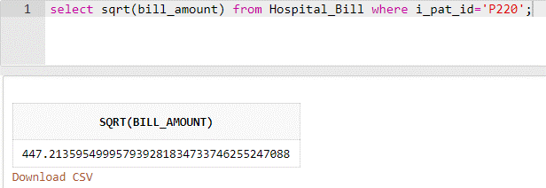

- Find the tan of all Bill Amounts.

Select tan(bill_amount) from Hospital_Bill;

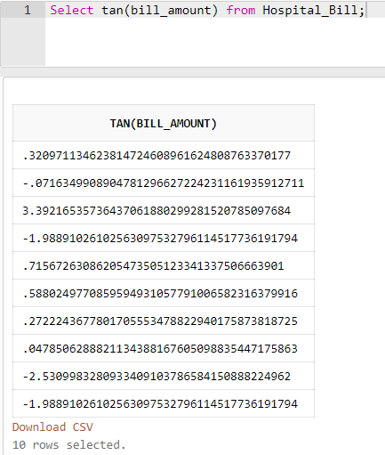

Q3. Using character function.
A3)
- Display the Patient Names in Lower Letters.

Select lower(pat_name) from Patient;

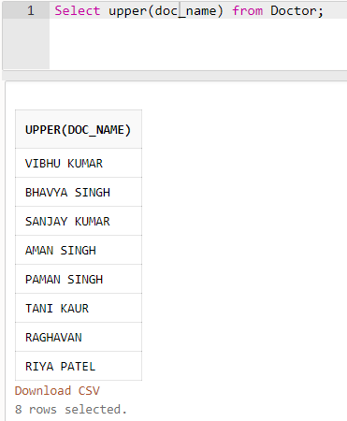
- Display the Doctor Names in Upper Letters.

